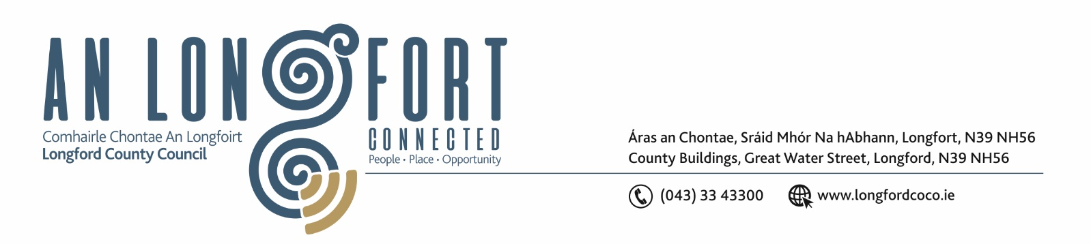

26th February 2020.

Chuig: Gach Ball don Chomhairle.

A Chomhairleoir,

You are requested to attend the Adjourned Special Meeting of Longford County Council to be held in the Council Chamber, Aras an Chontae, Great Water Street, Longford on Monday, 2nd March 2020 at
2.30 p.m. to transact business, as set out on the Agenda hereunder.

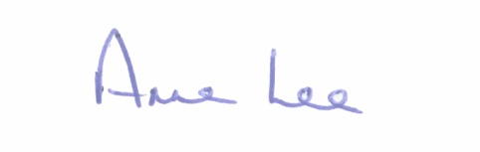
Mise le meas,

__________________
Anne Lee,
Meetings Administrator.

C L A R

Prayer before meeting

1. Declaration of Interest by Members.

2. Consideration of the filling of casual vacancy in the membership of Longford County Council in
accordance with Section 19 of the Local Government Act 2001 - following the election
of Joe Flaherty to Dáil Éireann in the recent General Election.



